- Forbidden City
- Bagan Temples & Pagodas
- Karnak Temple
- Teotihuacán

Wonder | Location | Image
Chichen Itza | Yucatán, Mexico | 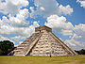
Christ the Redeemer | Rio de Janeiro, Brazil | 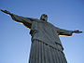
Colosseum | Rome, Italy | 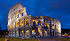
Great Wall of China | China | 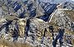
Machu Picchu | Aguas Calientes, Perú | 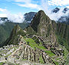
Petra | Jordan | 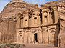
Taj Mahal | Agra, India | 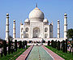
And one listing has honorary status: Giza Pyramid Complex  (The last remaining ancient wonder of the world) | Cairo, Egypt | 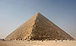

New Seven Wonders of the World
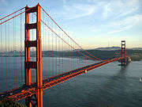 Golden Gate Bridge | 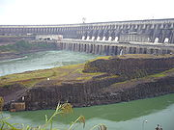 The Itaipu hydroelectric dam on the Paraná River
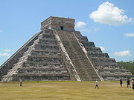 Chichen Itza | 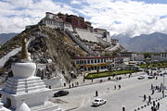 Potala Palace
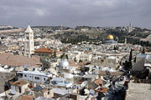 Old City of Jerusalem | 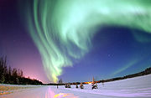 The Aurora Borealis or Northern Lights
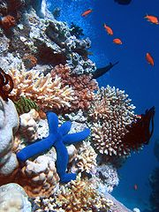 The Great Barrier Reef | 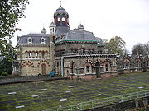 The London sewerage system's original Abbey Mills pumping station

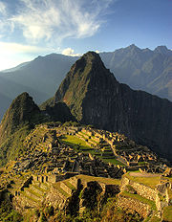

Machu Picchu

